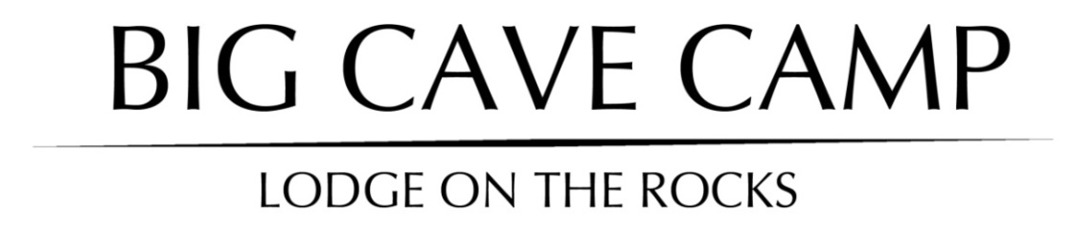
2018 INTERNATIONAL RACK RATES
1 January – 31 December 2018
Per person per night sharing  Including Vat | RACK
ACCOMMODATION:
Dinner, Bed & Breakfast |  | $160.00
Full Board (includes 3 meals a day) |  | $180.00
All Inclusive |  | $320.00
(Includes all meals, local drinks & activities / excludes Park Fees, imported drinks, transfers)
Single Supplement |  | $ 35
Children under 12 |  | Less 50%
Camping |  | $15
Children under 12 |  | Less 50%
Single Supplement |  | $35
Green Season Special
(8th Jan 2018 – 24th March 2018)
Dinner, Bed & Breakfast |  | $130
Full Board (includes 3 meals a day) |  | $145
ACTIVITIES
(Per Person Rate / Subject to change)
Drive the Big Cave property (1 hour) |  | $20
Guided Walk on the Big Cave property (1.5 hours) |  | $10
Matopos Tour / Game drive:
Option 1: Historical tour & rock art, |  | $55 excluding Park fees each
Rhodes Grave
Option 2: Visit to local village
Option 3: Rhino Tracking & game drive
Specialist Tours ( birding, cultural) |  | Price on request
National Park Fees (per day) |  | $15
Rhodes Grave Fees |  | $10
* Park fees subject to change
TRANSFERS: * Prices subject to change | Per Person, minimum 2 quoted pax
Bulawayo Airport - Big Cave Camp |  | $50
Bulawayo Central - Big Cave Camp |  | $30
Big Cave - Hwange Main Camp |  | $480 per vehicle
Meals  Breakfast  Lunch  Dinner |  | $15  $15  $20

Terms & Conditions
Payment policy:

Once reservations are confirmed in writing, full payment is due 30 days prior to arrival.

Reservations:

All reservations must be received in writing via e-mail. Once a booking confirmation has been sent back in writing, it is considered to be confirmed and cancellation terms and conditions apply. Full payment is due 30 days prior to arrival.
Any special dietary requirements are to be sent to our reservations department at least 30 days prior to arrival date. Failure to do so might mean that we are not able to fulfil the requests.
• All bookings are held as provisional until we receive confirmation in writing.
• Bookings due to travel within 3 months of the booking date, will be held on a provisional basis
for 2 weeks. Should we not receive written confirmation within 2 weeks of booking, you will be contacted to either confirm or release the booking.

• Bookings due to travel more than 3 months from booking date will be held on a provisional basis for a month.
• Should we not receive written confirmation within 1 month of booking, you will be contacted to either confirm or release the booking.
• If another booking is received; you will be informed in writing to secure your reservation with a written confirmation within 5 working days. Failure to revert back to us within the 5 working days will result in an automatic cancellation of the entire reservation.

Cancellation policy:

No. of days prior to arrival Applicable cancellation fee
60- 40 30% of the total value of reservation.
39 – 31 50% of total value of reservation.
30 or less 100% of total value of reservation.

Group reservations:

A group booking is classified as any booking of 6 or more guests per night.
Cancellation policy for Groups:

No. of days prior to arrival Applicable policy / cancellation fee

90- 76 20% of total value of reservation.

75 – 61 30% of total value of reservation.

60 -31 50% of total value of reservation.

30 or less 100% of total value of reservation.

Please Note:
• All accommodation rates quoted are subject to change without prior notice. However, rates quoted for confirmed bookings will be honoured.
• Visa fees & Park fees, where applicable, are not included.
• Visa and Master card facilities available

reservations@bigcavematopos.com www.bigcavematopos.com
Tel: +263 9 244990

